The purpose of this project was to design and implement a fully functional dashboard application for Grazioso Salvare, an organization that identifies and trains rescue dogs. The dashboard needed to connect to a MongoDB database, retrieve animal records from the Austin Animal Center Outcomes dataset, and provide an intuitive interface that allows users to filter, visualize, and explore the data. The required functionality included displaying an unfiltered dataset, offering interactive rescue-type filters, updating the data table dynamically, generating a breed distribution chart, and showing a geolocation map for selected animals. To demonstrate that the dashboard performs as intended, I captured screenshots of the initial dashboard state, as well as screenshots showing the results of the Water Rescue, Mountain/Wilderness Rescue, Disaster/Individual Tracking, and Reset filters. These images serve as proof that each component of the dashboard responds correctly to user interaction and meets the specifications outlined by the client.
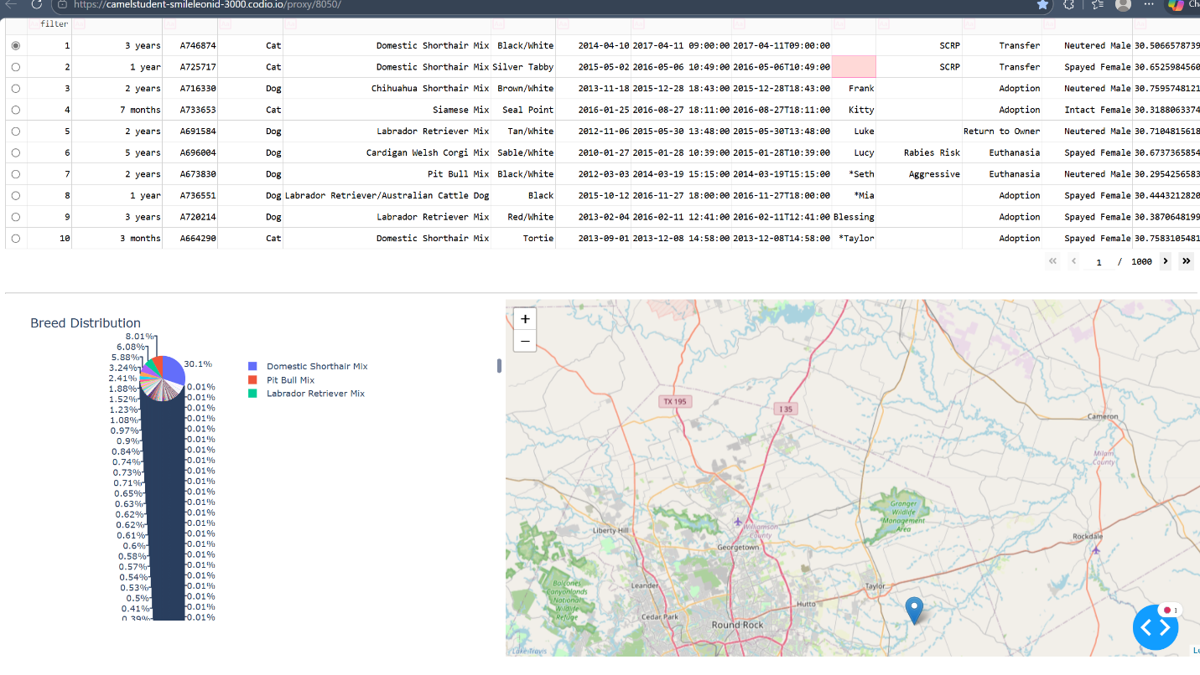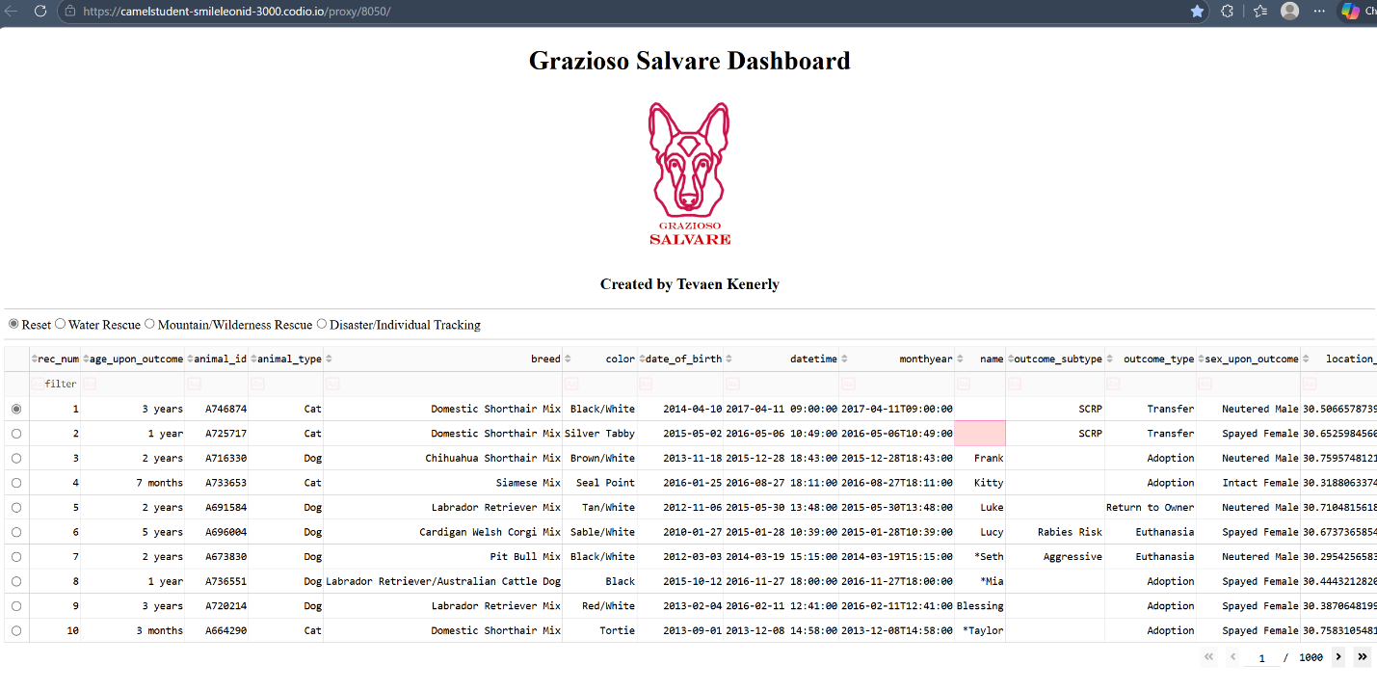
To achieve this functionality, I used a combination of Python, MongoDB, Dash, Plotly, and Dash Leaflet. MongoDB served as the model layer because its document-based structure is ideal for storing semi-structured data like the Austin Animal Center records. Its JSON-like documents map naturally to Python dictionaries, which made it easy to retrieve data through my CRUD module and convert it into Pandas DataFrames for display and analysis. MongoDB’s flexible schema, powerful query operators, and seamless integration with PyMongo made it the best choice for handling the project’s filtering requirements. The Dash framework provided both the view and controller layers of the application. Dash allowed me to build the user interface using Python alone, without needing JavaScript or HTML. Its callback system made it possible to link user inputs such as radio buttons, to updates in the data table, pie chart, and map. Plotly Express was used to generate the breed distribution chart, offering clean, interactive visualizations that update automatically when the dataset changes. Dash Leaflet was used to create the geolocation map, enabling the dashboard to display the coordinates of the selected animal with markers, tooltips, and popups. Together, these tools created a cohesive, interactive, and user-friendly dashboard.
The development process followed a clear sequence of steps. I began by completing the CRUD module in Project One, which established the connection to MongoDB and provided the basic Create, Read, Update, and Delete operations. Once the database connection was working, I loaded the full dataset into a DataFrame and created the initial unfiltered data table. I then developed the rescue-type queries based on the specifications provided by the client, ensuring that each query filtered by breed, age, sex, and animal type. After that, I added interactive radio buttons to the dashboard and connected them to a callback that updated the data table. I then created the breed distribution pie chart and the geolocation map, both of which respond dynamically to the filtered dataset. Finally, I added the Grazioso Salvare logo and my unique identifier to the dashboard, tested each component thoroughly, and captured the required screenshots for documentation.

During development, I encountered several challenges. One issue involved the MongoDB _id field, which caused the Dash DataTable to crash because ObjectID types are not compatible with the table’s serialization. I resolved this by dropping the _id column before loading the DataFrame. Another challenge involved running the dashboard in Codio, which does not allow direct access to localhost. To solve this, I used JupyterDash’s inline mode, which embeds the dashboard directly inside the notebook. I also had to adjust file paths for the logo image, since Codio requires precise relative paths based on the notebook’s directory structure. Additionally, I ensured that the CRUD module returned data in list format, since Dash cannot process cursor objects directly. By addressing these issues, I was able to create a stable, fully functional dashboard that meets all project requirements.

This project demonstrates how a Python-based MVC architecture can be used to build a complete, interactive data application. The combination of MongoDB, Dash, Plotly, and Dash Leaflet provided a powerful and flexible environment for developing a professional-grade dashboard that Grazioso Salvare can use to identify and evaluate potential rescue dogs. The final application is intuitive, responsive, and ready for future expansion.

